Reason for changing driver.c:
In driver.c, I had to change the path to get to “functions.h”. It was originally #include “functions.h” but it was changed to #include “.\src\functions.h” where it is currently located.
Screenshot for makefile:
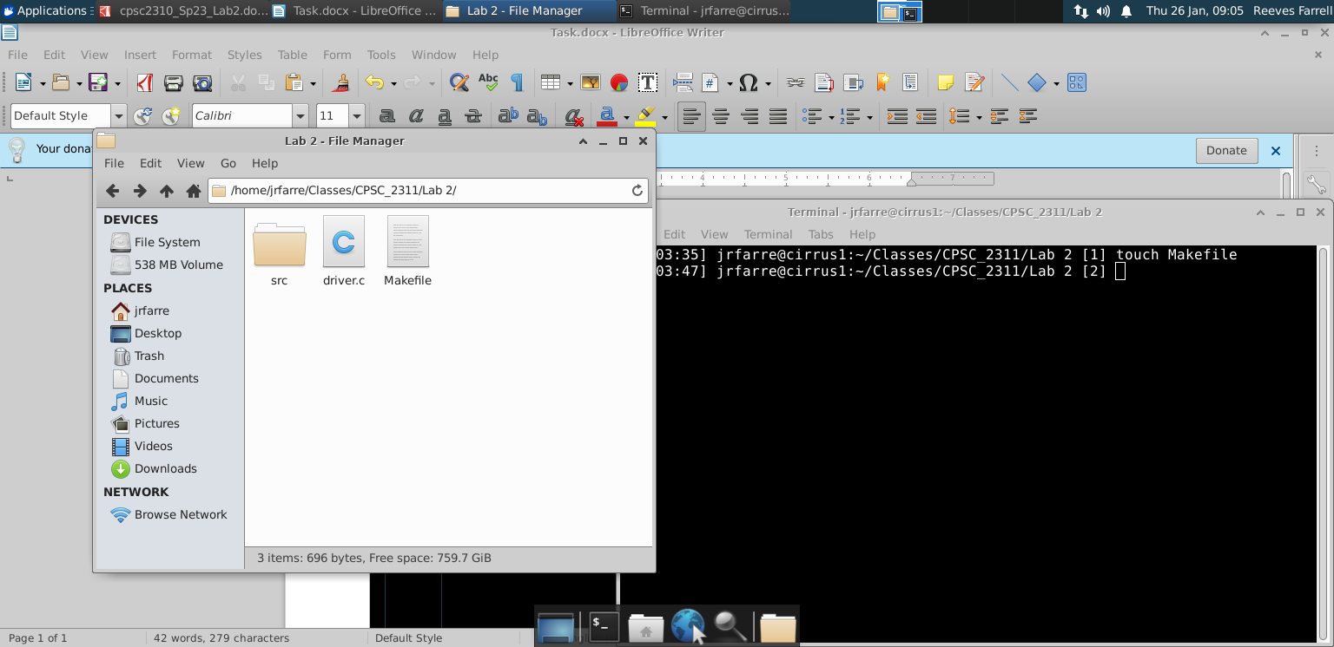
Screenshot for makefile with hello world:
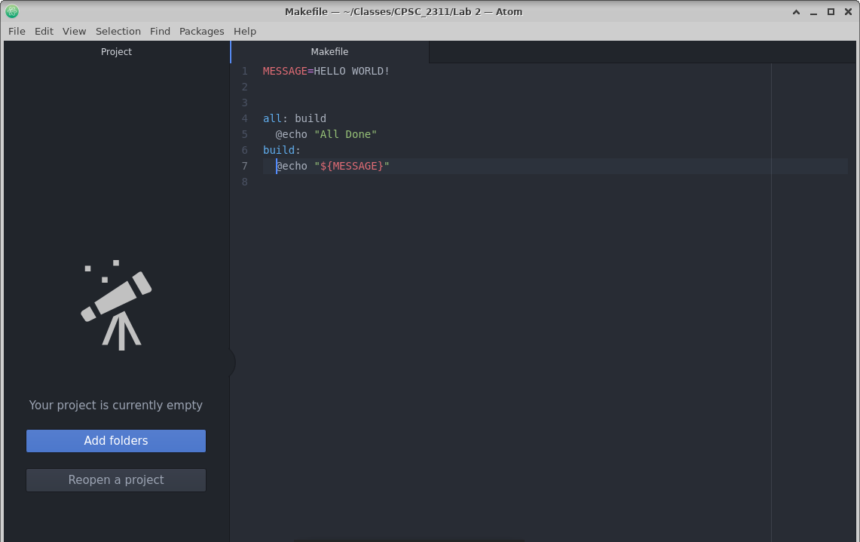
Make commands:
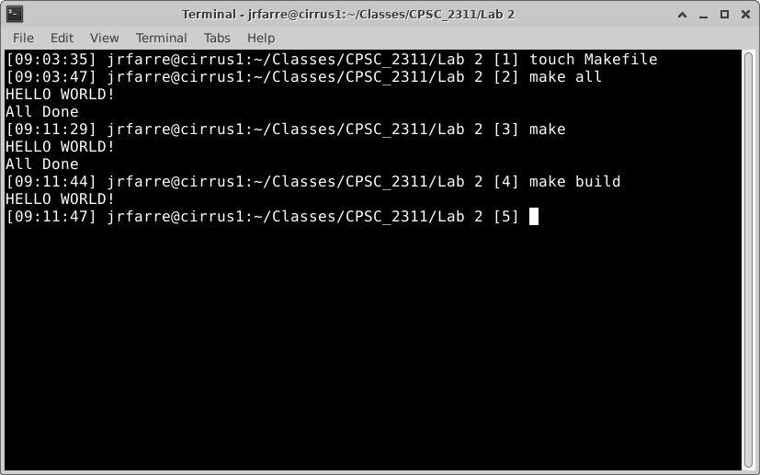
Tar and Untar:
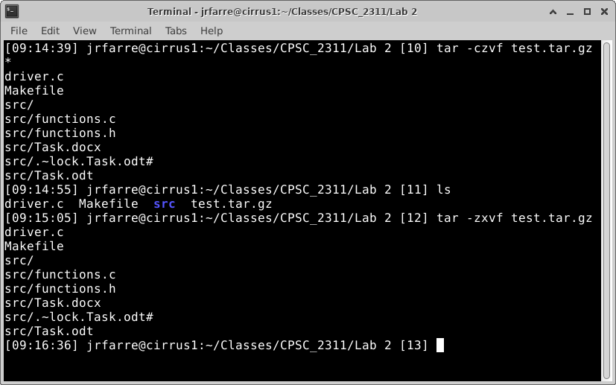
Makefile With Lab:
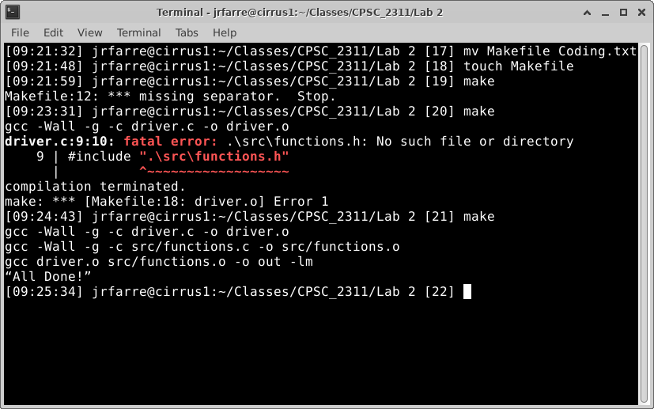

Make Which:
